OSSP-PRACTICAL-WEEK1
Task1: Develop a C program that demonstrates how a Linux operating system executes a command entered by a user by accepting a Linux command as input, creating a child process using the fork() system call, executing the command in the child process using an appropriate exec() system call, allowing the parent process to wait for the child using wait(), and displaying the Process ID (PID) of both the parent and child processes.
Source code:
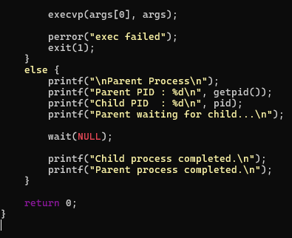
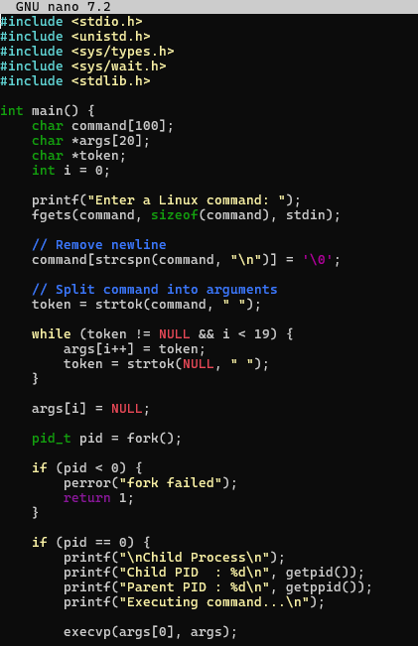
Output:
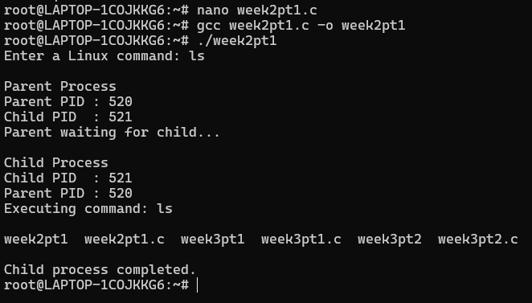
Observation: I learned how the Linux operating system creates a child process using fork() and executes a Linux command using the execvp() system call. I also understood how the parent process waits for the child process using wait() and how PID and PPID help identify the relationship between parent and child processes.
Task2: Using Linux terminal commands such as uname, lscpu, lsblk, ps, and top, investigate the relationship between hardware resources and operating system services. Prepare a report explaining how the operating system abstracts and manages CPU, memory, storage, and I/O devices.
Output:
Using command uname -a:
Using command lscpu:
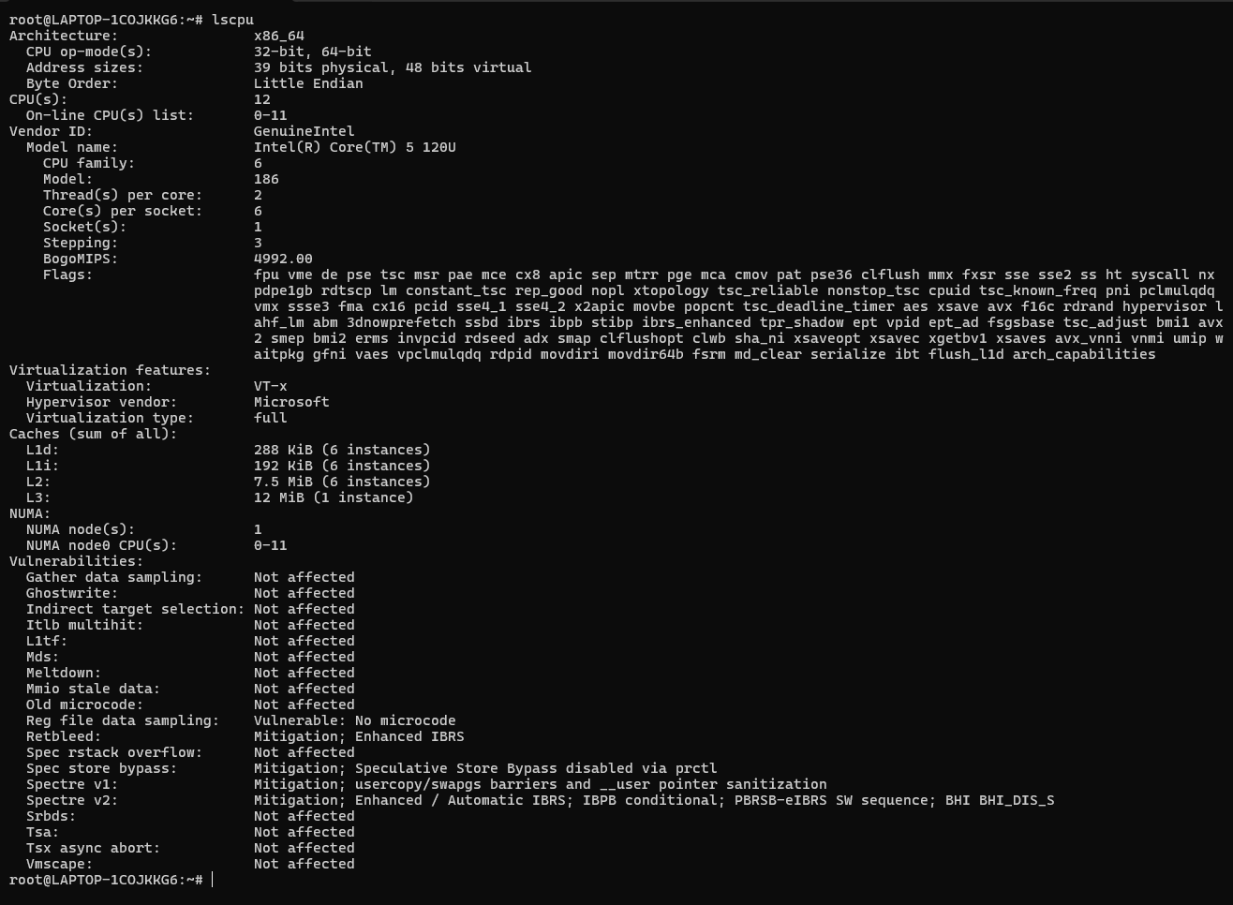
Using command lsblk:
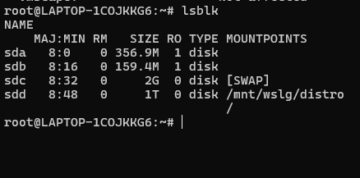
Using command ps:
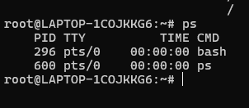
Using command top:
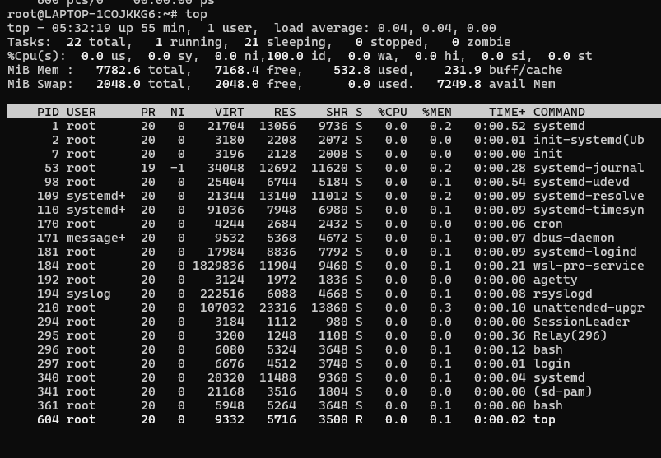
Observation: I learned how to use Linux commands to examine system hardware and running processes. I understood how the operating system manages CPU, storage, memory, and processes and provides these resources to applications through system services

